## Merchant Name *Plenful*

<https://app.hubspot.com/contacts/43610657/record/0-3/35681553063/>

## Implementation POC: Royce *(IM to fill)* CX POC: *[IMP to Add]*

### 

### 

| Notes Sections   *(AE to fill if they have, Implementation to be completion DRI on handoff)*   * Info on how merchant bills * SaaS fee with tiered usage commitments * usage can be based on volume of data for warehouse or amount of product SKUs they are using in the platform (or both) * currently eng team sends an HTML list monthly of customer usage that Daisy uses vlookup to calc usage for invoicing in QBO * ideally would want this calculated automatically and then see where overages exist for potential upsell into higher volume tier * billed monthly in arrears * System diagram: <https://docs.google.com/presentation/d/1R_i4H1Av5_tuP4E-EooVppgBwte-6uCf/edit#slide=id.g3267a82fcf0_0_517>   1) What is the merchant temperament? * Super nice and excited to work with us - has been following Tabs on linkedin for a whole   3) What are the Tabs features that the key POC cares about?   * SF & QBO integrations * Contract ingestion and automated product creation * Usage calculations * Cash forecasting * ARR * Revrec * Needs CARR |
| --- |

### Billing model *(Entire Section: Implementation to fill section)*

* Are there unique things about the customer creation process for this merchant?
* Information on how merchant bills
* How contract is broken up
* One off things to know about the merchant

### Contract Processing Steps *(Entire Section: Implementation/Success to fill Post-Go Live)*

1. **Mark the contracts as processed and assign customers with no BTs**
2. **~~General~~**
   1. ~~Most likely in the product/fees table in the contract.~~
   2. ~~There will be additional BTs in the appendix that need to be processed~~
      1. ~~If you see an Appendix that looks like the below, where you can’t tell which platform features correspond to each other in the quantity and pricing table, you can IGNORE for now~~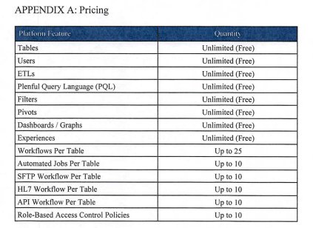

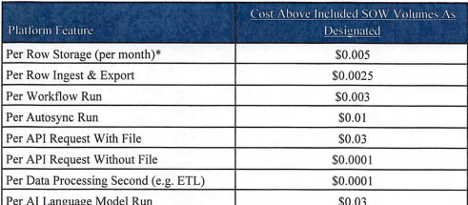

1. **~~Item Name:~~** ~~Use the product or service name listed.~~
2. **~~Quantity:~~** ~~Default to 1 unless explicitly listed.~~
3. **~~Total Price:~~**
   1. ~~Use the listed price from the contract.~~
   2. ~~Pay attention to the Subscription and Payments section or billing cadence category to determine the proper price~~
      1. ~~Product & fees table will often list a price that needs to be modified by the billing cadence.~~ 
         1. ~~For example: monthly pricing in table but invoiced quarterly -> will need to be multiplied by 3~~

~~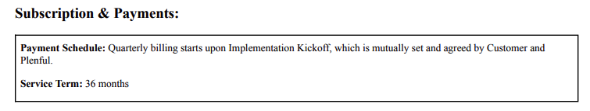~~

1. **~~Service Start Date:~~**
   1. ~~Use the Effective Date or last signature date.~~
   2. ~~The contract will often start after kickoff, but it won’t have the kickoff date listed.~~ 
      1. ~~If you can find the kickoff date, use that but if not, use the last signature date~~
   3. ~~If you see a short term (less than a year) like the below, automatically extend the BTs to be a year~~
      1. ~~~~
         1. ~~So for this one, service data and billing should go for 12 months~~
2. **~~Billing Start Date:~~** ~~Use the same date as Service Start Date unless a specific date is listed for the BTs~~
3. **~~Months of Service:~~** ~~Use the contract term length (e.g., 12, 36 months) as stated in the Subscription and Payments section~~
4. **~~Frequency:~~** ~~Align with the payment cadence in the subscription and payments section~~
5. **~~Net Terms~~**
   1. ~~Check the “Payment” section~~
      1. ~~“Customer will pay the fees within thirty (30) days from receipt of an undisputed invoice”~~
   2. ~~If none listed, default to 30 days.~~
6. **~~Tiered & Overage Pricing~~**
   1. ~~Processed tiered BTs on a monthly cadence~~
      1. ~~Need to pay attention to which quantities are included platform plan to determine how to structure the tiered BTs~~
         1. [~~Example #1~~](https://garage.tabsplatform.com/prod/contracts/c3f33ee3-b1ad-4dca-a0a0-1640ff217b90/terms/revenue)
            1. ~~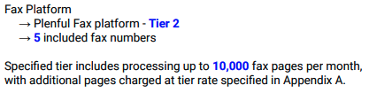~~
            2. ~~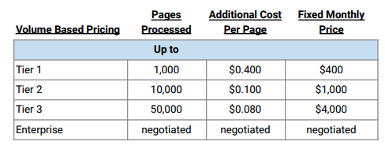~~
            3. ~~Additional pages needs to be a tiered BT~~

~~First tier is >10k for .10~~

~~Second tier is >50k for .08~~

~~This is because the first 10k is included~~

* + - 1. ~~Example #2~~
         1. ~~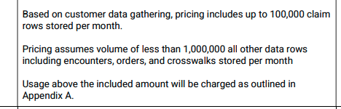~~
         2. ~~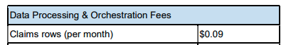~~
         3. ~~Will need to be a tiered BT with quantity >100k claims at $0.09~~
  1. ~~Process additional support hours as a separate unit BT - no need to make this tiered even if hours are included~~
  2. ~~Events should exist (or something very similar), but if you cannot find one that makes sense, please create the event~~

1. **~~Integration items:~~** ~~Ignore~~

1. Specifics processing things the merchant has requested that may differ by contract (e.g. always back-date invoice date to final day of the month)
2. Default Service Term
   1. If None Listed, Ops Default is 1 Year
3. Default Net Payment Terms
   1. If None, Ops Default is 0
4. Default Billing Frequency
   1. If None Listed, Ops Default is Monthly
5. How do we handle taxes as a line item?
   1. If None Listed, Ops Default is every tax line item becomes a BT

### Events Processing (if necessary) *(Entire Section: Implementation/Success to fill Post-Go Live)*

* Any important information on events billing

Integration Items Processing (if necessary)  
*(Entire Section: Implementation/Success to fill Post-Go Live)*

* What are the instructions for assigning integration items?
* Example: All Statsig integrations items should be labeled as “Sales”
* Example: All “Pinata” integration items should be labeled as “Software Subscription Bundle” unless otherwise noted by Merchant

Post Processing Communications (if necessary)  
*(Entire Section: Implementation/Success to fill Post-Go Live)*

* Does the Ops Team need to notify anyone on the team re: completion of processing batches in Implementation or Active phase?
* Who needs to be notified and when?
  + Example:
    - Who: Customer Success [Azmat Aziz] needs to be notified
    - Where: Messari internal merchant channel
    - When: contracts are processed [Merchant Phase: Active]

### Customer Information *(Entire Section: Implementation/Success to fill Post-Go Live)*

* Any important information on specifics customers of this merchant
  + Special memo’s certain invoices require
  + Invoice changes due to merchant/customer relationship

### Feature Requests *(AE to fill for all requests prior to Imp handoff, Imp to fill prior to go-live/Success to fill to fill Post-Go Live)*

* FR 1
  + What is it
  + Why it's important
  + Urgency

### Merchant Calls *(AE to fill for all videos prior to Imp involvement, Imp to fill prior to go-live/Success to fill to fill Post-Go Live)*

* Loom recording links by dates